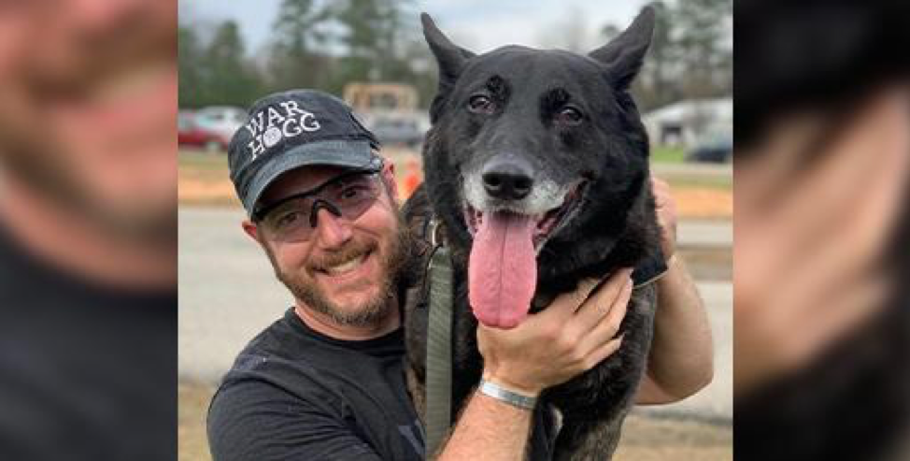

Super Scout and Regan’s K-9 Hero of the Week: Combat Assault Dog Duco

This week, we want to memorialize an outstanding K-9 that worked as a Combat Assault Dog for U.S. Army Special Operations Forces.

Dutch Shepherd Duco served with handler Rick Hogg, supporting Operation Enduring Freedom from 2012-2017.

After losing his Belgian Malinois, Marco, in 2012, Hogg was given the unit’s spare or “float” dog, Duco. Hogg’s first thought after losing Marco was that he didn’t want this other dog. Anyone well-familiar with both breeds will appreciate their personality differences. But Duco quickly grew on him.

Before long, handler and dog were completely bonded. Duco’s ability to switch gears from laid back, chilling out in the kennel, to “game on,” made him uniquely effective. As Hogg explains, “His drive sold me.”

“He was an absolute beast on the battlefield,” he said. It was a perfect pairing. “Duco was an extension of me.”

Just six months after they were paired up, during a nighttime raid in Afghanistan, Duco and Hogg fell approximately 30 feet from a helicopter. Hogg was knocked unconscious, but Duco seemed to survive unscathed.

The handler/K-9 relationship is hard to define. Handlers know all too well the risks these remarkable dogs take when they head out into harm’s way. Coming to terms with that reality is never easy. Hogg drew on his faith every time Duco was tasked to venture into dangerous territory. He said a simple prayer:

“God, bring him back to me.”

And He always did.

As a dual-purpose K-9, Duco was trained to detect and to bite. He had a knack for finding bad guys where human eyes failed. He knew how to detect explosives long before the men he worked with could. This dog quickly became the one everyone hoped to have working with them. He was revered as a force-multiplying K-9 security blanket.

It is because of Duco and dogs like him that many soldiers are alive today. Hogg speaks with emotion and reverence about Duco’s heroic contributions to the fight:

“I’m here on this planet because of that dog.”

Years after the helicopter incident, Rick assessed that Duco may be suffering from some long-term injuries he sustained in the fall. He made the decision to retire Duco, allowing him to live out his days in the comfort of his own home.

In a serendipitous coincidence, Hogg was scheduled to retire at the same time that Duco was wrapping up his military career.

Prior to 2000, most military K-9s were euthanized when taken out of service. Thanks to a bill passed by Congress, these heroic dogs were given a second chance at living out their twilight years in a comfortable home environment.

Fortunately, Duco was well-suited for family life and made an excellent transition. Not all war dogs are able to do this, but Duco was special.

Both Hogg and Duco were able to retire together.

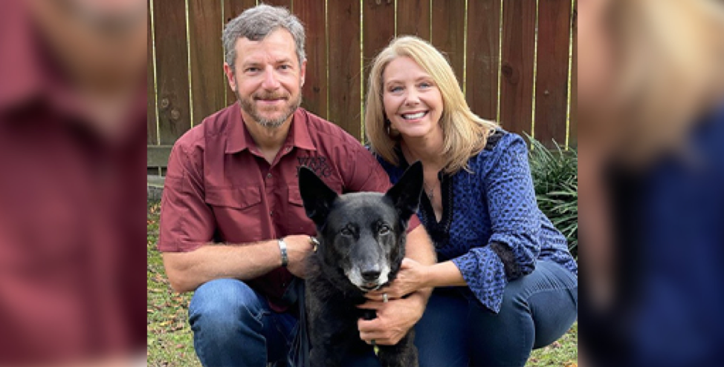

At home, Hogg continued to work with Duco, keeping him active and sharp. Little did he know that his wife was offering this specialized combat assault dog a few cushy pet perks.

She introduced him to goldfish crackers and table scraps. He quickly developed a reputation as “the heater,” because his hot breath was always on the family’s legs in newfound anticipation of tasty handouts.

Hogg’s wife bought Duco toys, which he loved, particularly his highly prized squeaky moose. He also spent a good bit of time on the couch. He even slept in the couple’s bed, if he wanted. The dog fully embraced home life. As Hogg explained, “He earned it.”

In November of 2020, Duco was diagnosed with osteosarcoma, an aggressive form of bone cancer, in his rear right leg. Veterinarians felt they might be able to prolong and improve his quality of life by amputating the leg and administering chemotherapy. Hogg and his wife made the difficult decision to proceed with amputation and chemo, hoping for the best.

This bought the family over half a precious year together with their beloved dog.

Sadly, seven months after his surgery, Duco’s cancer returned, and this legendary, heroic and brave dog succumbed to the disease on July 5, 2021.

Rick believes that Duco is the gold standard upon which all other combat assault dogs are judged. In Rick’s words, he would have a “fleet of Ducos” if he could.

This K-9 and his handler have built a legacy together, and Hogg wants to ensure that Duco’s service to our country will never be forgotten. When asked if he believes Duco is in a better place, Hogg replies emphatically, “100 percent, dogs go to heaven!”

We think he’s right, and we are grateful that he was willing to share the life and accomplishments of his awesome dog with the world.

To learn more about Duco and Rick Hogg, check out warhogg.com and visit their Instagram page.

ATP COO comment: I cannot even express the gratitude that I have for the war dogs that fought by my side and protected us. Many of us are walking around today because they gave the ultimate sacrifice.

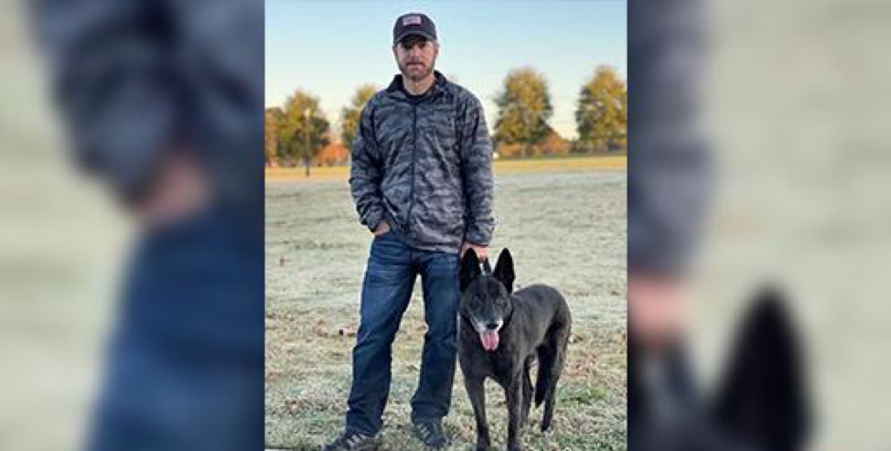
Support The Missionhttps://victormarx.com/donate/

The Daily Intelligence Brief Premium — The DIB P is a thoughtfully curated daily memo, filled with news from trusted sources around the world and delivered straight to your inbox each day. Get up to speed on the stories driving the week’s news, and make up your own mind instead of allowing mainstream media outlets to tell you what to think. In addition to bringing you interesting and newsworthy articles, we offer something you won’t find anywhere else:

All Things Possible's INTELLIGENCE TEAM provides thoughtful, INSIDER PERSPECTIVE and ANALYSIS of the events shaping the news.
Sources for the DIB Premium include local and national media outlets, state and government websites, proprietary sources, in addition to social media networks.

